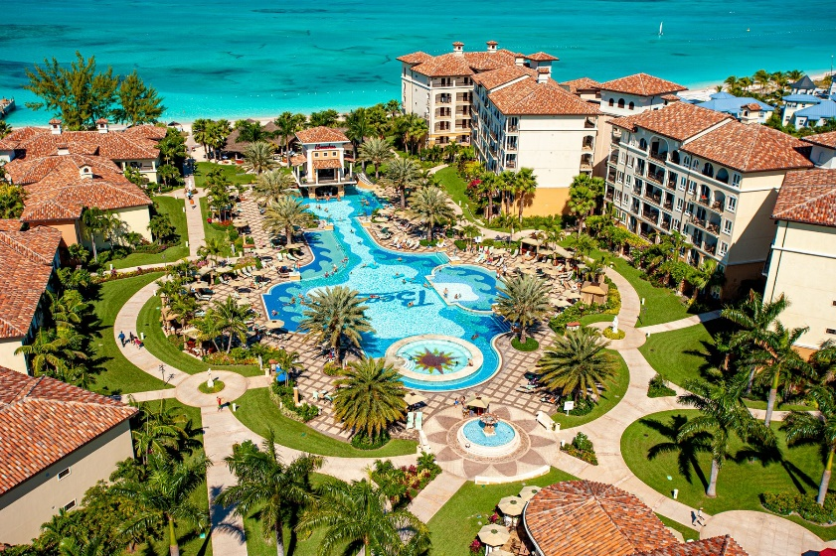





A snazzy downtown hotel, or a dreamy Caribbean beach resort? The choice between hotels vs resorts can take some serious thought ahead of your getaway and the best decision tends to depend on the reason for travelling.

Are you just looking for a place to stay near the conference center downtown? Or are you going on a long-awaited vacation with the family? Are you planning to spend most of your time outside to explore your destination all day? Or are you planning to relax at the pool and do as little as possible?

**Typically, the main difference between resorts and hotels is in the amenities**

Hotels cater to travellers who need a place to spend the night at a certain destination, resorts tend to be destinations in themselves. Resorts often have a more spacious layout, offering their guests everything they need in one place.

**Hotels tend to be less private than resorts because of the square footage available to guests**,

**In most cases, hotels just don’t have everything you’ll need for a vacation all in one place as would be seen in a resort**,

For some hotels, this isn’t an issue as they’re located smack in the middle of things, so guests can access the things they need with relative ease. Therefore, **location is often key when choosing a hotel to spend the night at**.